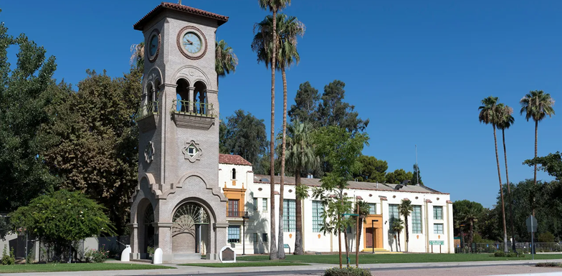

KERN COUNTY
POINT IN TIME COUNT
2025 REPORT


TABLE OF CONTENTS
Acknowledgements 1
Introduction 4
Methodology 4
Current and Comparative Data 5
Key Findings 6
Population Demographics 6
Living Accommodations and Duration for Unsheltered Homeless Population 8
Length of Current Episode of Unsheltered Homelessness 8
Perceived Causes of Unsheltered Homelessness 8
Health and Unsheltered Homelessness 9
Special Populations of Interest 9
Additional Homeless Populations 10
Conclusion 10
Appendix B: Unsheltered Count Density Maps by County 12
Appendix C: Historical PIT Count Data by Household Composition 14

Acknowledgements
The Bakersfield-Kern Regional Homeless Collaborative (BKRHC) Point in Time (PIT) Count Committee extends gratitude to all volunteers and partnering agencies who contributed to this endeavor; their efforts were instrumental in the success of the count. Over 462 volunteers registered to participate in the 2025 PIT Count. Employees from the County of Kern, City of Bakersfield, homeless service providers, and community organizations have provided their time planning, implementing, and conducting the count.

Thank you to the Mission at Kern for providing logistics space for the PIT Count, to the PIT Committee members and committee chair Manuel Vieyra with Flood Ministries of Bakersfield for providing leadership and guidance in planning for such a huge community event, to partners with lived experience of homelessness for gifting us with insight where it was needed, and to the BKRHC staff for their commitment and support to the work.

Thank you to Suzanne Baehr and the Kern County GIS team for supporting the app survey work and data needs of the PIT Count volunteers.

Thank you to City and County partners in government, code enforcement, fire/emergency services, law enforcement, parks and recreation, human services, public works, and aging and adult services for helping navigate through the work.

Thank you to Dr. Ashleigh Herrera with California State University of Bakersfield (CSUB) for providing Narcan training for all volunteers and other CSUB members for participating during the count.

Thank you to the County of Kern and participating organizations who provided their time, energy, and support to the Kern County 2025 PIT Count, including volunteers from:

Adventist Health □ Akido Labs □ Anthem Blue Cross □ Bakersfield American Indian Health Project □ Bakersfield College □ Bakersfield Recovery Services □ Be Finally Free □ CA Mentors □ California State University Bakersfield □ California Veterans Assistance Foundation □ City of Arvin □ City of Bakersfield □ City of Ridgecrest □ City of Wasco □ City Serve □ Clinica Sierra Vista □ Community Action Partnership of Kern □ Community College Services □ Community Vitality □ County of Kern □ Darlene Denison Insurance Agency □ Department of Corrections □ Department of Human Services □ Department of Veterans Affairs □ Employers’ Training Resource □ Fairfax School District □ Flood Ministries □ Garden Pathways □ Greater Bakersfield Legal Association □ Good Samaritan Hospital □ Habitat For Humanity □ Health Net □ Housing Authority of the County of Kern □ Intrepid Business Resources, LLC □ Kern Behavioral Health and Recovery Services
□ Kern County Assessor □ Kern County Grand Jury □ Kern County Superintendent of Schools □ Kern Health Systems □ Kern High School District □ Kern Medical □ Lamont Elementary School District □ LifeHouse Church □ Maturango Museum □ Mercedes of Bakersfield □ Mercy House □ No Sister Left Behind □ Office of Assemblywoman Dr. Jasmeet Bains □ Omni Family Health □ Pathways □ Redeem Home □ Rosedale School District □ The Dream Center □ The Garden Living at Mill Creek □ The Open-Door Network □ United Way of Central Eastern California □ Victory Outreach □ Wasco Free Will Baptist Church □ Women's Center High Desert

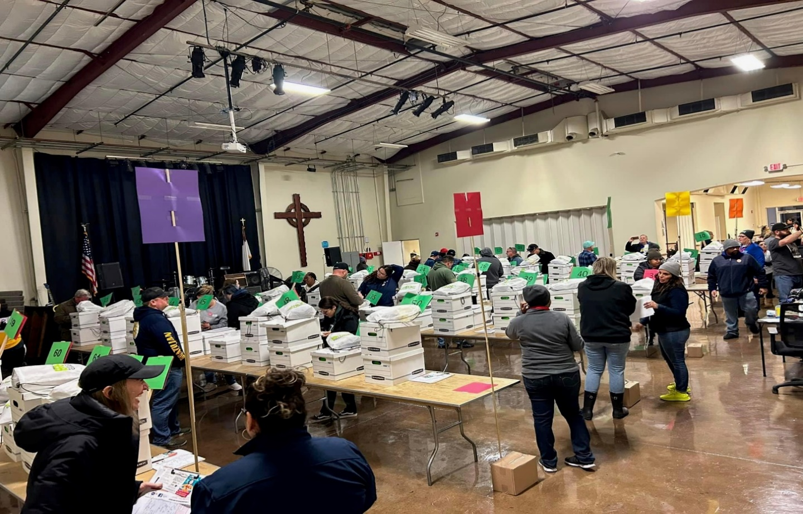
Kern County 2025 PIT Count Summary

The 2025 Point-in-Time Count was an endeavor taken on by a dedicated group of individuals and volunteers through a community-wide effort to cover Kern County. The count conducted from January 29th through 31st comprised a single night shelter count and a three-day unsheltered count.

2025 KERN COUNTY SHELTERED / UNSHELTERED POPULATIONS
47% | 53%
SHELTERED | UNSHELTERED
1213 individuals | 1398 individuals
2022 – 2025 HOMELESS POPULATION COUNTS

 | ADULTS | ADULTS W/ CHILDREN | CHILDREN | TOTAL
2022 | 1361 | 75 | 167 | 1603
2023 | 1747 | 76 | 125 | 1948
2024 | 2450 | 85 | 134 | 2669
2025 | 2325 | 121 | 165 | 2611
RACE *
AMERICAN INDIAN, ALASKA NATIVE,  OR INDIGENOUS | 2%
ASIAN OR ASIAN AMERICAN | 1%
BLACK, AFRICAN AMERICAN, OR AFRICAN | 23%
HISPANIC/LATINA/E/O | 25%
MIDDLE EASTERN OR NORTH AFRICAN | 1%
NATIVE HAWAIIAN OR PACIFIC ISLANDER | 1%
WHITE | 42%
MULTIPLE RACES  * List includes race and ethnicity only or race and ethnicity with Hispanic/Latina/e/o combinations. | 7%

HOUSEHOLDS COMPOSITION
ADULTS WITH NO CHILDREN
 | 36% | 64%
 | Sheltered | Unsheltered
 | 2325 Individuals
ADULTS WITH CHILDREN
 | 97% | 3%
 | Sheltered | Unsheltered
 | 121 Individuals
CHILDREN ONLY
 | 98% | 2%
 | Sheltered | Unsheltered
 | 165 Individuals
SUB-POPULATIONS
CHRONICALLY HOMELESS | 53%  Sheltered  410 Individuals | 47%  Unsheltered  365 Individuals
VETERANS | 49%  Sheltered  51 Individuals | 51%  Unsheltered  53 Individuals
TRANSITIONAL YOUTH | 34%  Sheltered  76 Individuals | 66%  Unsheltered  149 Individuals
AGE
Under 18 years | 6% – 165 individuals
18 – 24 | 9% – 225 individuals
25 – 34 | 19% – 487 individuals
35 – 44 | 26% – 639 individuals
45 – 54 | 20% – 526 individuals
55 – 64 | 15% – 384 individuals
65 years and older | 7% – 173 individuals

Introduction
The United States Department of Housing and Urban Development (HUD) defines homelessness as individuals who lack resources and support networks to obtain permanent housing and can be categorized as those who are literally homeless, imminently homeless, unaccompanied youth or families with children/youth, and individuals or families fleeing or attempting to flee various forms of violence such as domestic violence, dating violence, stalking, sexual assault, or other life-threatening conditions.

The nationally conducted PIT Count is an annual snapshot of sheltered and unsheltered individuals experiencing homelessness within a geographic area. Specifically, Kern County covers over 8,100 square miles with a variety of ecosystems ranging from high deserts, chaparral-laden mountains, and fertile agricultural land within the valley.

Although HUD requires Continuums of Care (CoC) to conduct counts biennially, the Bakersfield-Kern Regional Homeless Collaborative completes an annual count to identify changes within the homeless delivery system and understand the needs within the community.

Methodology
The 2025 PIT Count utilized a HUD approved methodology for conducting interviews for individuals experiencing homelessness in Kern County that ensures consistency, allowing for meaningful analysis and standard. The methodology involves a combination of interviews, surveys, and observations by trained volunteers. The shelter count was completed using a survey hosted within the ArcGIS Survey 123 application, a geographic information system that works by collecting data via survey administration, and occurred on the night of Tuesday, January 28, 2025. The unsheltered count was completed the following morning on Wednesday, January 29, 2025, utilizing the unsheltered version of the survey application, which was also hosted within ArcGIS Survey 123.

BKRHC PIT Committee and Governing Board approved two (2) additional days to continue the count for encampment areas along the Kern River and the rural areas. The Flood Ministries Outreach Team searched and conducted interviews. These efforts aimed to identify unsheltered individuals and families who may not have been identified on Wednesday, January 29, 2025.

There was no change in the methodology due to the need to have an accurate data comparison for three consecutive years. We pursued the updated guidance provided by HUD, including several required contingencies to ensure surveys were not duplicated on individuals already surveyed on prior days. These measures included comparison of personally identifiable information including name, date of birth, demographic information, current living situation and survey screening questions (e.g., have you already been surveyed).
The PIT count utilizes an in-person interview of individuals experiencing homelessness throughout Kern County. For those individuals who were not able to complete a survey, various account methods are used in situations where it was impossible or unsafe for a volunteer to survey an individual. An observational survey was completed, and trained outreach staff conducted interviews on two additional days for accuracy. For instances where demographic (race and ethnicity) data could not be collected, a data resource known as the HUD data extrapolation tool was used to obtain missing data extrapolated from the data that was present. The data collected is compiled and undergoes a thorough process that included scrubbing/cleaning, deduplication, error-checking within the extrapolation tool, analysis, post analysis review, and entry into HUD's reporting system (HUD Data Exchange – HDX 2.0), which conducts automated, real-time error tracking. Any errors in HUD's reporting system were caught and corrected before the data submission could be completed.

Even prior to official submission to HUD, the data and reports are reviewed with the CoC's Governing and Executive Boards.

Current and Comparative Data

During the 2025 PIT Count, a total of 2611 individuals were counted, of which 1213 were comprised of sheltered individuals, and 1398 unsheltered individuals. This nominal decrease has resulted in flatting the curve of homelessness in Kern County.
(Appendix C and Table 6).

The year-over-year change resulted in a 17% increase in sheltered individuals while the unsheltered individual count decreased by 10%. This data reflects:
- The Metro Bakersfield unsheltered number decreased by 10% to 1185.
*Metro Bakersfield includes Bakersfield and Oildale
- An increase in the sheltered population reflects an additional 236 individuals who are now sheltered.
- There was a 12% decrease in unsheltered chronically homeless individuals in the County of Kern.

Figure 1. Total homeless population by PIT year.

Sheltered and Unsheltered Status by PIT Year.

Figure 2. Comparison of sheltered (blue) and unsheltered (green) populations by PIT year.

Key Findings

Population Demographics

Age
The 2025 PIT count shows the number of adults (aged 25 – 44) experiencing homelessness decreased by 15.9% compared with the 2024 PIT count. Below shows the distribution of homelessness based on age.

Figure 3. Age Brackets for Homeless Population

Race
During their last review of PIT count collection criteria, HUD made the decision to consolidate the ethnicity and race categories to be more inclusive and indicative of individuals’ specific ethnic and racial representation. The result is a combination of ethnicity and race where specific combinations could include the ethnicity and race alone, the ethnicity and race with included Hispanic/Latina/e/o representation, or multiple selections.
(see Table 1).

Table 1. Race Breakdown Among Sheltered and Unsheltered Homeless Population.
Race | Sheltered | Unsheltered | All People
American Indian, Alaska Native, or Indigenous (only) | 1% | 0% | 1%
American Indian, Alaska Native, or Indigenous & Hispanic/Latina/e/o | 0% | 0% | 0%
Asian or Asian American (only) | 0% | 0% | 0%
Asian or Asian American & Hispanic/Latina/e/o | 0% | 0% | 0%
Black, African American, or African (only) | 10% | 13% | 23%
Black, African American, or African & Hispanic/Latina/e/o | 0% | 0% | 0%
Hispanic/Latina/e/o (only) | 7% | 18% | 25%
Middle Eastern or North African (only) | 0% | 0% | 0%
Middle Eastern or North African & Hispanic/Latina/e/o | 0.0% | 0.0% | 0.0%
Native Hawaiian or Pacific Islander (only) | 0% | 0% | 0%
Native Hawaiian or Pacific Islander & Hispanic/Latina/e/o | 0% | 0% | 0%
White (only) | 24% | 18% | 42%
White & Hispanic/Latina/e/o | 3% | 0% | 3%
Multi-Racial & Hispanic/Latina/e/o | 0% | 2% | 2%
Multi-Racial (all other) | 1% | 3% | 4%

Living Accommodations and Duration for Unsheltered Homeless Population
The overall number of unsheltered individuals who provided a response to their current living situation resulted in a majority living outdoors, typically in places not meant for human habitation including parks, freeway underpasses, riverbed locations, abandoned buildings, and along canals or alleyways. Unsheltered individuals encountered during the PIT count were also living in abandoned buildings, cars, or garages.

Length of Current Episode of Unsheltered Homelessness
There were 386 individuals who experienced homelessness for the first time and were also interviewed during the unsheltered homeless count. As for the length of the current episodes for unsheltered homelessness, those who have been homeless for a year or more had the highest number. (see Figure 4).

Figure 4. Count of length of current episode of unsheltered homelessness.

Perceived Causes of Unsheltered Homelessness
Data on perceived causes of homelessness was collected from 823 unsheltered respondents who provided a response to this survey question. The top causes identified were health, mental health, and substance use disorder related reasons (200), household or family issues (138), employment related causes such as lack of wages, job loss, or lack of jobs (150), and mortgage or rent related issues (46). Other potential causes of homelessness include incarceration or personal choice.

Health and Unsheltered Homelessness
There was a total of 249 individuals who self-reported health conditions within the unsheltered population ranged from a single disease or morbidity to as high as seven (7) co-morbidities. These diseases include asthma, diabetes, heart disease, hepatitis C, HIV/AIDS, tuberculosis, and valley fever.

Table 2. Morbidity and Co-Morbidity within the Unsheltered Homeless Population.
Number of Self-Reported Diseases (Morbidities) | Count
1 | 157
2 | 50
3 | 25
4 | 13
5 | 2
6 | 0
7 | 2

Health insurance data was again included as part of the survey questions for this year's PIT count. Access to healthcare is a major social determinant of health, and access to healthcare insurance is an important factor in resolving one’s homelessness. During this year’s count, the number of individuals who provided a response regarding health insurance increased (499 in 2024 versus 574 in 2025). The data revealed an increase in the number of those experiencing unsheltered homelessness who have Medi-Cal or Medicare compared to last year.

Table 3. Insurance Among the Unsheltered Homeless Population.
Insurance Type
Medi-Cal | 527 | Veterans’ administration | 7
Medicare | 21 | Other | 17
State health insurance | 1

Special Populations of Interest
Three populations of interest within the overall homeless population include individuals who are chronically homeless, those with current or prior military service, and individuals aged between 18 – 24 years (youth). The count for these populations is listed below.

Table 4. Count of Homeless Populations of Interest.
Homeless Populations of Interest | Sheltered | Unsheltered
Chronically homeless | 324 | 457
Veterans | 44 | 49
Youth | 61 | 86

Additional Homeless Populations
Other populations of focus for individuals experiencing homelessness include those with self-reported mental illness, substance abuse, HIV/AIDS, and those who identify as survivors of domestic violence (see Table 5).

Mental Illness
There was a total of 245 adults who self-reported a serious mental illness. More unsheltered individuals reported a serious mental illness than their sheltered counterparts.

Substance Use Disorder
653 individuals in the homeless population self-reported substance use disorder with the majority also being unsheltered. Substance use disorders range from alcohol, drug, or alcohol and drug use.

HIV/AIDS
There were an equal number of individuals who self-reported living with HIV/AIDS that were also experiencing sheltered and unsheltered homelessness with 19 respondents.

Table 5. Count of Additional Homeless Populations.
Additional Homeless Populations | Sheltered | Unsheltered
Adults with a serious mental illness | 30 | 215
Adults with a substance use disorder | 149 | 504
Adults with HIV/AIDS | 10 | 9

Conclusion
The Continuum of Care (CoC) along with the City of Bakersfield and the County of Kern have made significant progress in combating homelessness aimed at reducing the number of individuals experiencing homelessness. The Point-in-Time (PIT) Count is a vital tool to understand the scope of homelessness, create strategies to improve outcomes in making homelessness rare, brief, and non-recurring. BKRHC utilizes PIT Count data to guide collaborative planning with the city, county, and service provider organizations to efficiently allocate resources focused on designing a system of supportive services, shelter and permanent housing.
The PIT Count underscores the power of community collaboration and highlights our collective alignment to enhance the quality of life for all Kern County residents.
Appendix A: Definitions
Adult
An individual who is aged 25 and older.

Bakersfield-Kern Regional Homeless Collaborative (BKRHC)
The primary entity charged with responsibility for overseeing CoC functions as mandated by HUD, including submission of the annual CoC Notice of Funding Opportunity (NOFO), HMIS oversight, Point In Time Count, Housing Inventory Chart, as well as other annual reports.

Chronically Homeless Individual
An individual or family head of household with one or more disabling conditions who has been continuously homeless for 1 or more years and/or experienced 4 or more episodes of homelessness in the last 3 years.

Families
A household that consists of at least one adult who is 18 years of age or older and at least one child who is under 18 years of age.

Housing and Urban Development (HUD)
The U.S. Department that funds low-income and affordable housing initiatives, including the McKinney-Vento Homeless Assistance Act, through the HUD Continuum of Care Program and Emergency Solutions Grant Program.

Point In Time (PIT) Count
The Point-in-Time (PIT) count is a count of sheltered and unsheltered people experiencing homelessness on a single night in January.

Sheltered Homelessness
A state of homelessness where an individual is currently residing in an emergency shelter, navigation center, or transitional housing.

Unsheltered Homelessness
A state of homelessness where an individual is currently residing in a place not meant for human habitation, including vehicles, sidewalks, abandoned buildings, parks, freeway underpasses, or encampments.

Unaccompanied Youth
Youth under the age of 18 and individuals between 18 through 24 years of age experiencing homelessness and without a parent or legal guardian.

Veteran
An individual who has served on active duty in the Armed Forces of the United States.

Appendix B: Unsheltered Count Density Maps by County
The included density maps provide an overall view of the homeless population spread throughout Kern County and within metropolitan areas. Additionally, count totals are divided up by city.

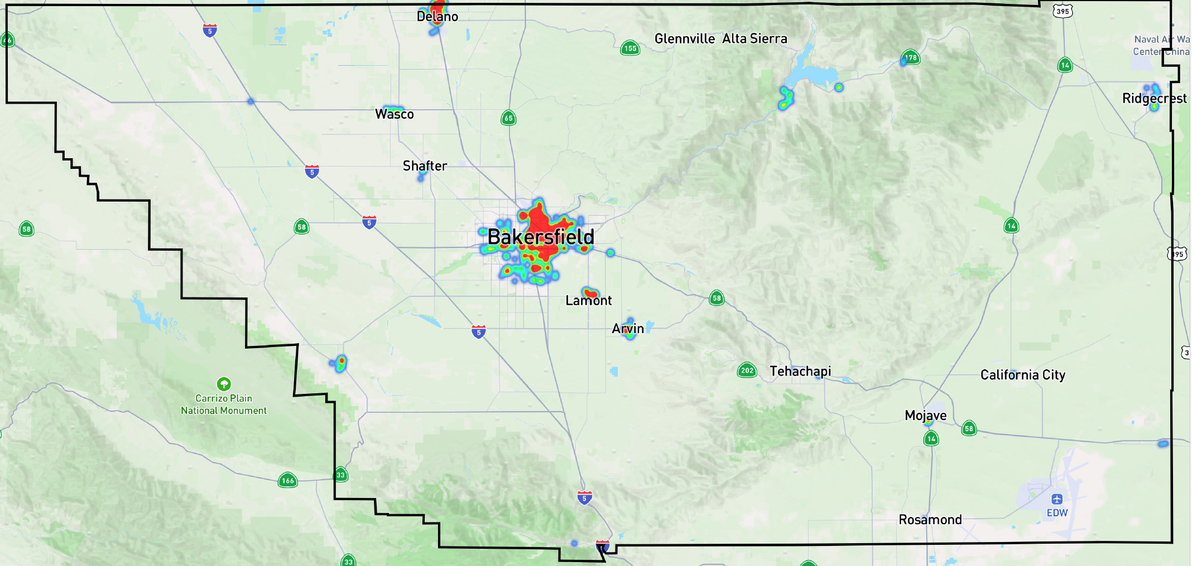 Figure 5. Density map of Kern County for the 2025 Point-in-Time Count
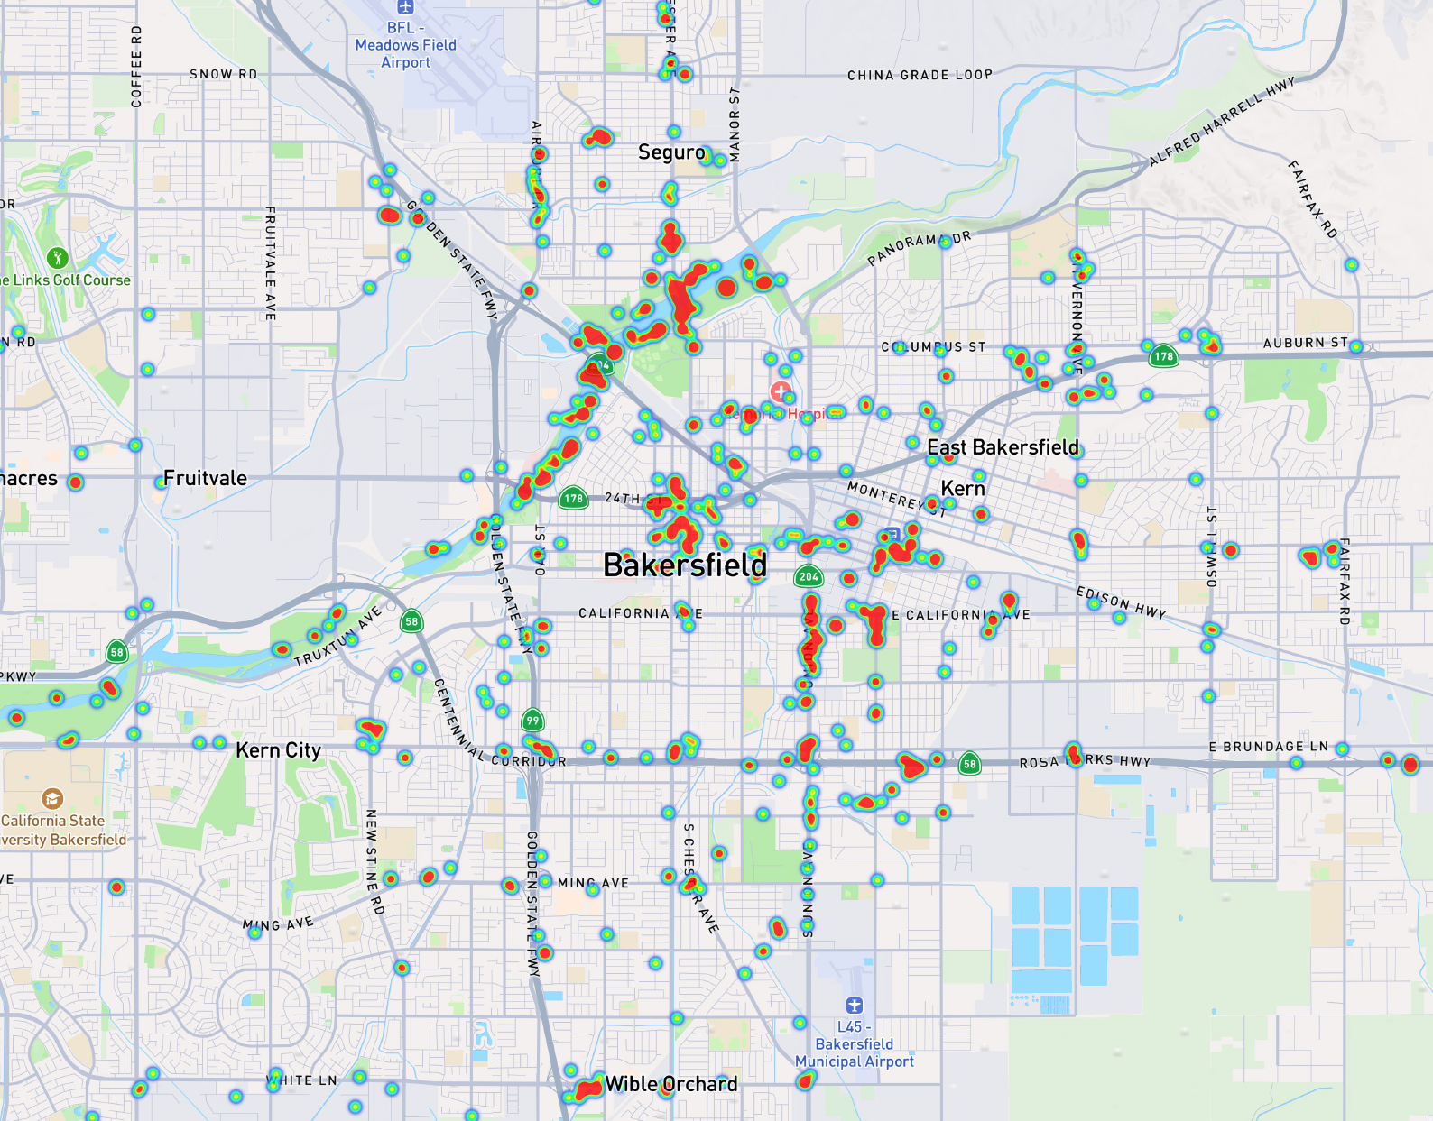
Figure 6. Density map of metropolitan Bakersfield for the 2025 Point-in-Time Count.

Appendix C: Historical PIT Count Data by Household Composition

Table 6. Historical PIT Count Totals by Household Composition and Percent Change
Year | Adults | Adults’ w/ Children | Children | Total Persons | % Change From Previous Count
2025 Total | 2325 | 121 | 165 | 2611 | -2.3%
2024 Total | 2450 | 85 | 134 | 2669 | 37%
2023 Total | 1747 | 76 | 125 | 1948 | 22%
2022 Total | 1361 | 237 | 5 | 1603 | -25%
2021 Total | 1633 | 174 | 343 | 2150 | 36%
2020 Total | 1359 | 79 | 142 | 1580 | 19%
2019 Total | 1115 | 74 | 141 | 1330 | 50%
**2021 PIT Count was not conducted in person due to COVID, HMIS data used.
Table 7. Unsheltered PIT Count Totals by City
CITY | 2024 Unsheltered Count | 2025 Unsheltered Count
Arvin | 0 | 19
Bakersfield | 1202 | 1084
Bodfish | 2 | 2
California City | 0 | 3
Delano | 86 | 93
Ford City | 1 | 1
Frazier Park | 3 | 1
Inyokern | 1 | 0
Lake Isabella | 16 | 19
Lamont | 13 | 17
Lost Hills | 0 | 1
Mojave | 7 | 7
Oildale | 122 | 101
Ridgecrest | 9 | 10
Rosamond | 8 | 2
Shafter | 2 | 3
Taft | 39 | 13
Tehachapi | 11 | 3
Wasco | 35 | 12
Wofford Heights | 2 | 0
** 5 Unsheltered count records did not indicate an associated city.
Table 8: Metropolitan and Rural Data by Shelter Status
By Area and Shelter | Adults | Adults’ w/ Children | Children | Total People
Metro Bakersfield – Sheltered | 957 | 78 | 159 | 1194
Rural Sheltered | 9 | 10 | 0 | 19
Total County Sheltered | 966 | 88 | 159 | 1,213
Metro Bakersfield – Unsheltered | 1153 | 26 | 6 | 1185
Rural Unsheltered | 201 | 7 | 0 | 208
Location Not Indicated | 5 | 0 | 0 | 5
Total County Unsheltered | 1359 | 33 | 6 | 1398
Total Metro Bakersfield | 2106 | 104 | 165 | 2375
Total Rural | 214 | 17 | 0 | 231
Location Not Indicated | 5 | 0 | 0 | 5
2025 Combined | 2325 | 121 | 165 | 2611
2024 Total | 2450 | 85 | 134 | 2,669
2023 Total | 1,747 | 76 | 125 | 1,948

